Themes

Cultural Object
[Ancient copy.png]
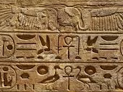

Photograph
[EP.00614 Bennett Album.jpg]
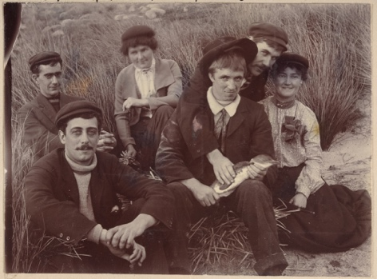

Art
[cm-activity-three.png]
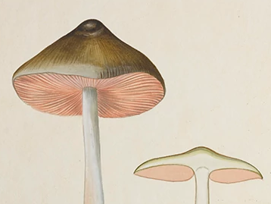

Sound Recording
[GMC_335a-PF.jpg]
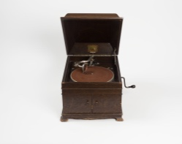

Film

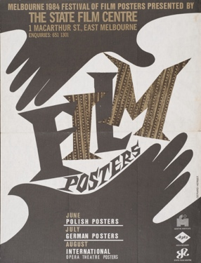

Technology
[Physics Electrometer copy 2.jpg]
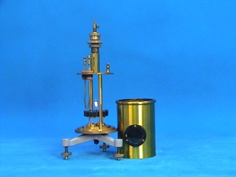

Collections
Medical History Museum
[MHM01314_001.jpg]
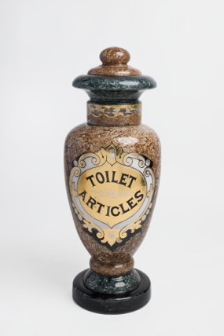

Grainger Museum Collection
[Hardanger_Fiddle.tif]

University Art Collection
[ola cohn 2019_0054_006_000 copy.jpg]

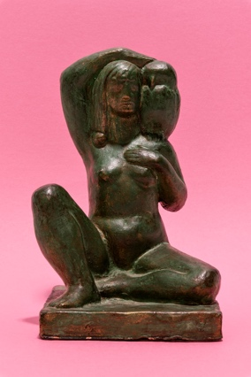

Henry Foreman Atkinson Dental Museum
[mdhs-stagging.png]
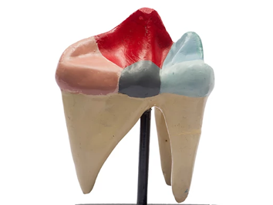

Harry Brookes Allen Museum of Anatomy & Pathology
[516-102472_a.jpg]
